Appendix 2a



ERAR Project -Volunteer Application Form

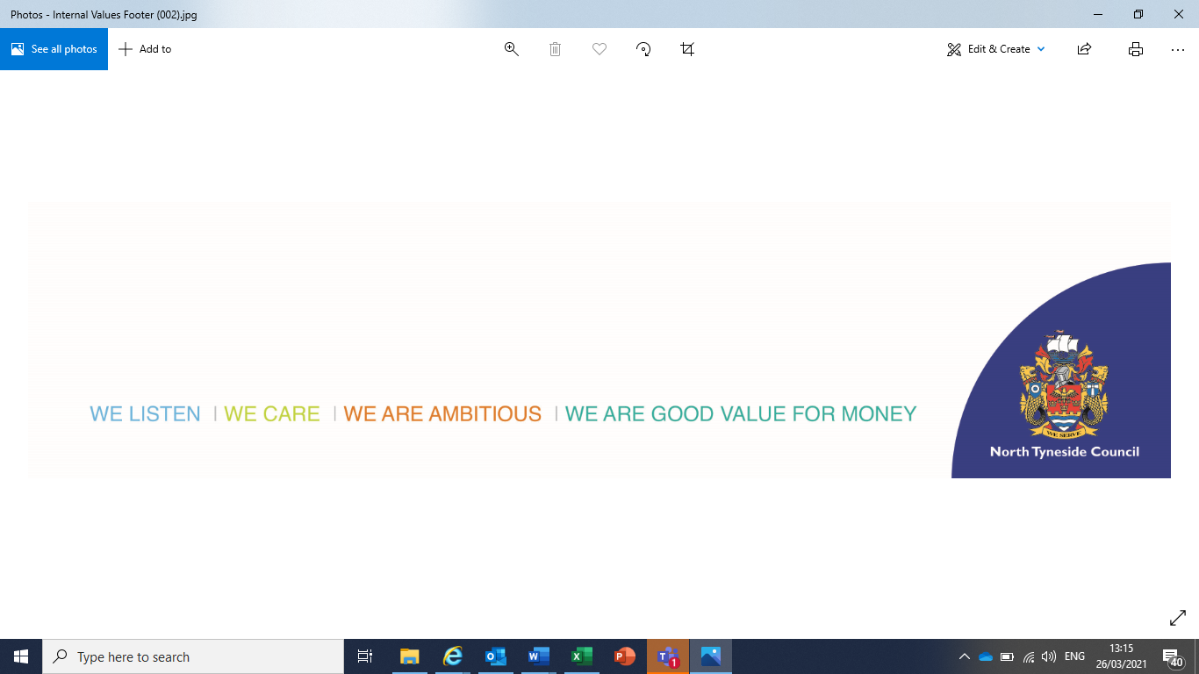**Date:** January 2022

**Application Form**

Thank you for your interest in volunteering with ERAR and North Tyneside Council. Volunteers pay a valued and significant role in the success or our work and we hope you will be able to join our team.

Please refer to the application form guidance for support with completing this form, and for information about next steps. If you require a copy of this form in an alternative format or language, please let the recruiting volunteer supervisor know.

|  |  |
| --- | --- |
| **Name of Volunteer Role**  **Reference Number (if applicable)** |  |

**Part A: Personal Details**

|  |  |  |  |  |  |
| --- | --- | --- | --- | --- | --- |
| Mr/Mrs/Miss/Ms/Other:  (please specify) |  | Forenames: | |  | |
| Surname: |  | | Known as (if applicable): | |  |
| Address Inc. Postcode: |  | | | | |
| Contact telephone number |  | | | | |
| E-mail: |  | | | | |

**Assistance with interviews/selection process**

|  |
| --- |
| In order to help us remove any barriers in our selection process, please let us know if you would like any particular assistance for your interview or selection process. You do not have to provide information about any health condition you may have, only the assistance you need. |
|  |

**Part B: Knowledge, skills, and experience**

|  |
| --- |
| Using the volunteer role description as a guide, please let us know why you are applying for the role and how you feel your knowledge, skills and experience (paid or unpaid) make you suitable for it. If completing this on a hard-copy and you wish to add further information, please attach additional sheets |
|  |

**Further Information - Optional**

|  |
| --- |
| Please provide any further information, not covered in the previous section, that you would like to provide in support of your application, or that you would like to be taken into consideration. |
|  |

**Declaration**

|  |  |  |  |
| --- | --- | --- | --- |
| I certify that, to the best of my knowledge, all the information I have given is complete, correct and factual. I understand that deliberately giving false or incomplete answers would exclude me from consideration or may lead to the ending of the volunteer agreement.  Please note: By submitting this form electronically you are accepting this declaration. | | | |
| Signed: |  | Date: |  |

**Thank you for your application to volunteer with North Tyneside Council.**

The information you provide in this form will be used to help us consider your application and help us decide whether you are a suitable match for the role.

If you are appointed to a volunteer role this information will be transferred to your personal volunteer file. North Tyneside Council respects your right to privacy. Full details of how we use the information collected from you is contained in our Employee Privacy Notice. A copy of this is available on the North Tyneside Council website, together with details of your rights under Data Protection Legislation. Alternatively you can request this from the recruiting volunteer supervisor.